Driver Status report query:

Purpose: Query system to discovery what LOAD Drivers and Broker's drivers are currently hauling.

History: Currently we have a working report, but it pulls data that is written on loads and isn't real time. When users go back and change various load information, the report data becomes convoluted.

Mission: We need to transition this report to pull real time information with a complex query that builds the info real time from the live database.

Example report:

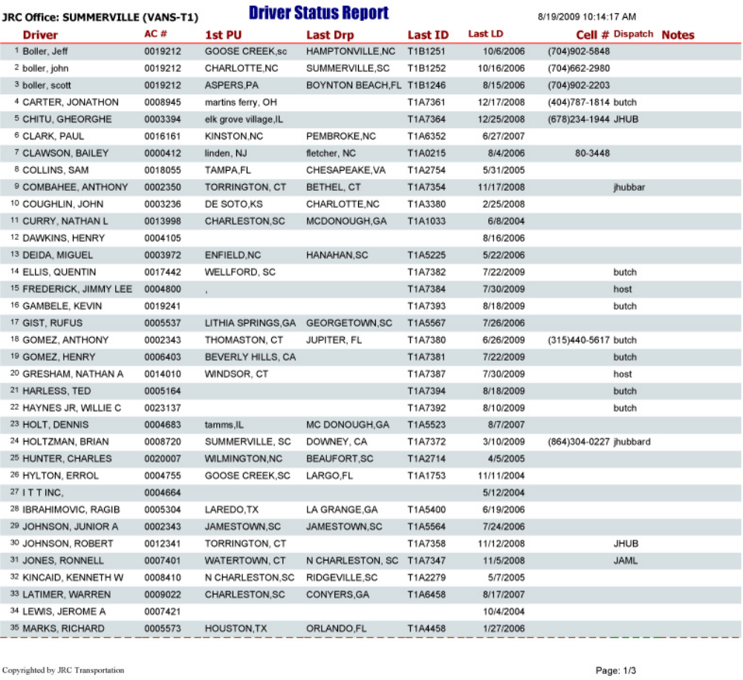

The logic

- Reports need to start by pulling data from a specific office number. We will use 0000080 as an example for the query at hand. This will be the specified office.
- Next, query must build a list of all drivers from the table tblSalesPersonMasterfile > DriverName assigned to specified office.
- Next, query must add to the list of drivers drivers from the table tblBKRSalesPersonMasterfile > DriverName assigned to specified office.
- For each driver Query, one at a time, searches for the most recent load ID among table tblOOLoadSheetHeader using this logic:
- Most recent load date first
- If there are more records of matching load date, select highest number based on last 5 digits
- Repeat above step for each broker driver.
- Once proper load numbers discovered, display data found supporting the load data for the display, which is located across 4 tables.

Building the data:

Sorting by Driver name, alphabetical mix of the drivers and broker drivers for specified office.

The fields (returned data):

Driver: These were pulled in order to build your query and get to this point. Sort alphabetical.

AC# Driver account number.

1st PU. 1st pickup in line for the load ID.

Last Drop Last drop in line for the load ID.

Last ID Load #

Last LD Load Date

Cell# Cellphone number

Dispatch The dispatcher who wrote the load.

Notes (empty) space left for hand written notes, no data.

Deliverable:

Example query that can be tested and run in the DNN SQL window? All we need is the written query to give us guidance to build the microsoft report from it.

